Non- Relational Database Design and Implementation

Trayvonious Pendleton

WGU

Course Number: D597

STUDENT ID: 011205284

PART A1

EcoMart, a growing marketplace for eco-friendly products, faces challenges in managing its dynamic and diverse inventory. The company needs an efficient way to store and manage product details such as descriptions, prices, availability, sustainability certifications, and user reviews. Their existing relational database cannot handle the semi-structured nature of this data or accommodate the frequent updates and seasonal changes in the product catalog. Additionally, as user traffic and product offerings grow, the system lacks the scalability and flexibility required to maintain optimal performance. These limitations hinder EcoMart's ability to deliver a seamless and responsive experience to its environmentally conscious customers.

# PART A2

A NoSQL database is an ideal solution for EcoMart's challenges due to its inherent flexibility, scalability, and ability to handle unstructured and semi-structured data. Unlike relational databases, a document-based NoSQL database such as MongoDB allows for storing diverse product attributes in a JSON-like format, supporting products with varying characteristics and nested structures. This flexibility eliminates the need for a fixed schema, enabling rapid adaptation to changes in the product catalog. Additionally, NoSQL databases are designed for horizontal scalability, which ensures that EcoMart can efficiently manage increasing data volumes and user traffic. The performance benefits, including faster query execution and real-time data updates, further support the growing needs of EcoMart's platform.

## PART A3

The most suitable NoSQL database type for EcoMart is a document-based database such as MongoDB. Document databases store data in JSON-like structures, making them well-suited for managing diverse and dynamic product information. MongoDB offers features like dynamic schema design, allowing EcoMart to handle products with varying attributes and nested data such as user reviews and certifications. Moreover, MongoDB's support for sharding enables horizontal scaling to accommodate high volumes of data and traffic, ensuring reliable performance as the business expands. The database's indexing and replication features also contribute to fast data retrieval and fault tolerance, meeting EcoMart's operational needs.

### PART A4

EcoMart’s database will be designed to manage and optimize access to a wide range of product-related information. Each product document will include attributes such as name, price, description, availability, sustainability certifications, and user reviews. The database will also categorize products by tags and categories for better organization and efficient search capabilities. User reviews will be stored as nested data, capturing ratings, comments, and timestamps. Real-time updates allow administrators to add new products, adjust pricing, and manage inventory based on seasonal changes. This design ensures quick access to customer information and enables EcoMart to provide personalized recommendations and filters, creating a seamless shopping experience aligned with its sustainability mission.

PART B

Several strategies will be incorporated into the database design to ensure scalability and accommodate EcoMart's growing data volumes, dynamic inventory updates, and increasing user traffic. First, horizontal scalability will be achieved through sharding, allowing data to be distributed across multiple servers. For example, products can be sharded by category or region, ensuring an even load distribution as the database grows. Replication will also be implemented to provide fault tolerance and high availability, ensuring data is copied across multiple nodes. This allows uninterrupted access even if a node fails, with data replicated across multiple data centers for reliable access in different geographic locations. Additionally, caching will reduce latency by storing frequently accessed data, such as popular products or top-rated items, in an in-memory caching layer like Redis.

Efficient indexing will improve query performance, with indexes applied to fields such as product name, category, and price to accelerate search operations. For example, indexes on sustainability certifications or user ratings will allow users to filter products based on specific criteria quickly. The schema-less nature of the proposed document-based database will provide flexibility to support dynamic growth, enabling new product attributes or categories to be added without requiring schema migrations. Furthermore, robust monitoring tools like MongoDB’s built-in monitoring or third-party solutions like New Relic will identify performance bottlenecks and ensure optimal database health through regular maintenance. By combining these strategies, EcoMart's database design will deliver the scalability, reliability, and performance needed to support its mission and growing customer base**.**

PART C

To ensure robust privacy and security in the proposed database design, several measures will be implemented to protect sensitive customer and business data while ensuring compliance with regulations such as GDPR and CCPA. Data encryption will safeguard information at rest and in transit, using AES-256 for stored data and TLS protocols for secure communication. This ensures that customer details, such as payment information, remain inaccessible to unauthorized parties. Role-based access control (RBAC) will also limit data access based on job roles, allowing only authorized personnel to interact with specific data, reducing the risk of internal misuse. For example, developers will work with anonymized data in test environments, while administrators can configure the database without accessing sensitive user information.

To enhance security further, the system will employ data masking and anonymization for non-essential environments like analytics and testing, ensuring minimal exposure of sensitive details. Secure authentication mechanisms, such as multi-factor authentication (MFA), will provide an added layer of protection, requiring users to verify their identity beyond a simple password. Regular audit logging will track database activities, documenting actions such as access, updates, and deletions, enabling prompt identification of unauthorized or suspicious behavior. Finally, encrypted backups and a comprehensive disaster recovery plan will protect against data loss and ensure swift restoration in case of an attack or hardware failure. These measures create a secure and resilient database framework, ensuring EcoMart’s data remains protected while fostering customer trust and regulatory compliance.

**PART D1**

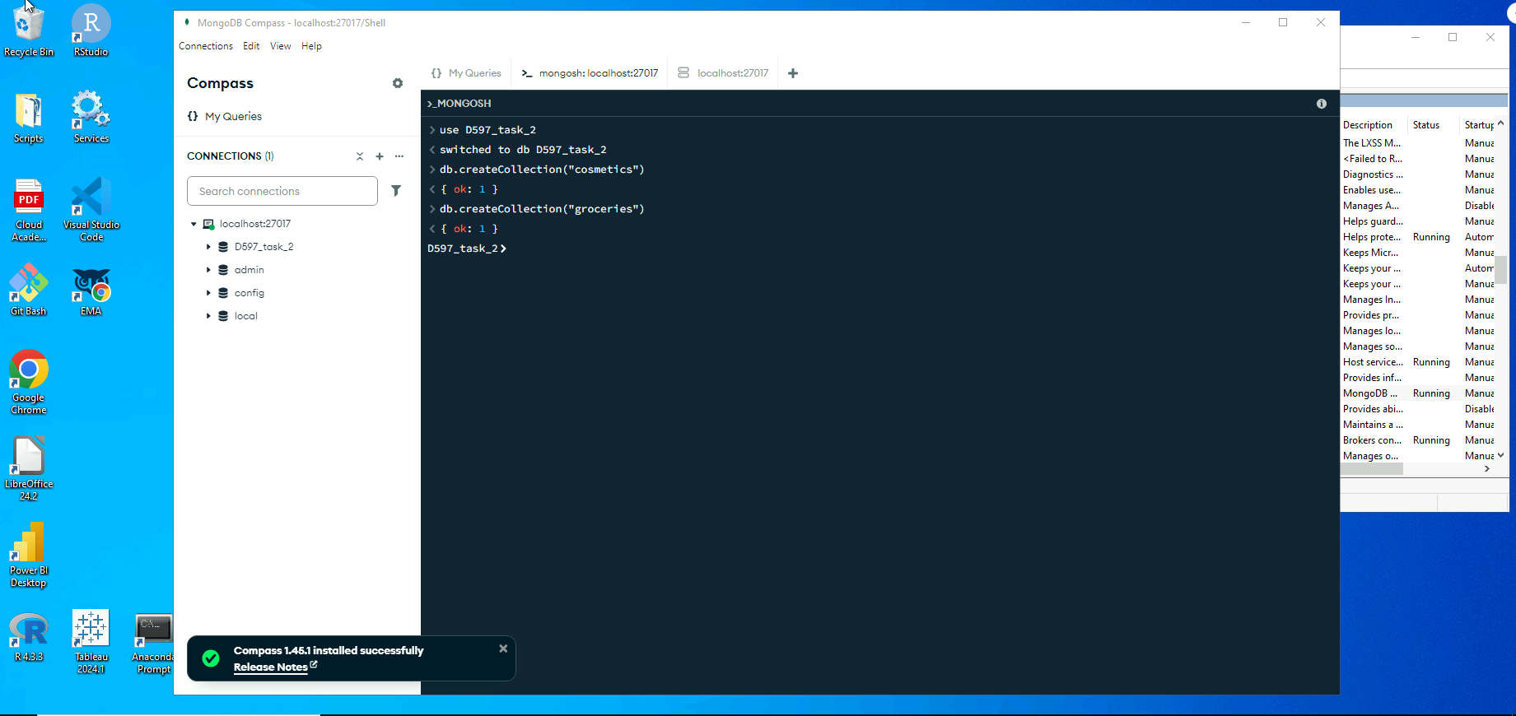

**PART D2**

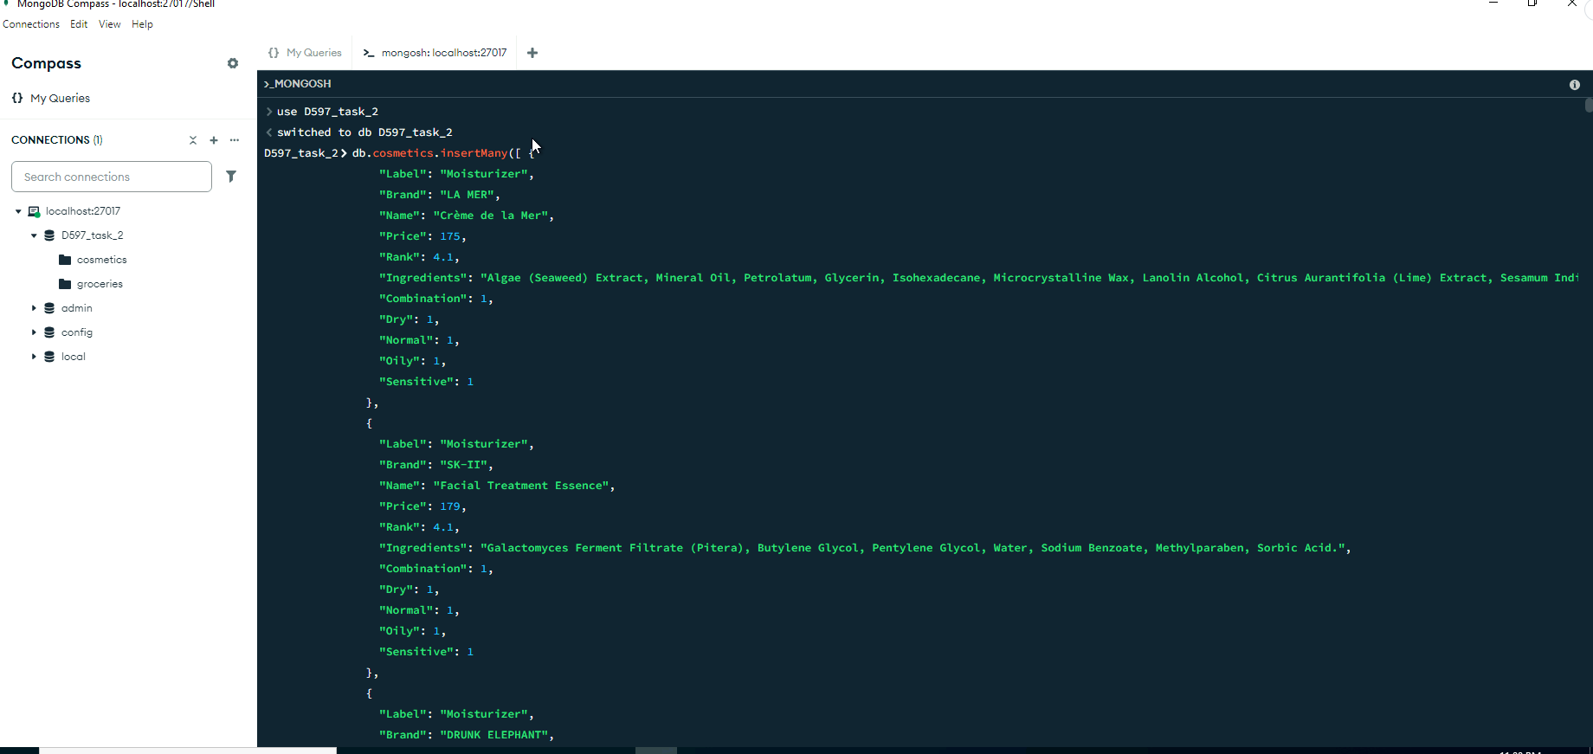

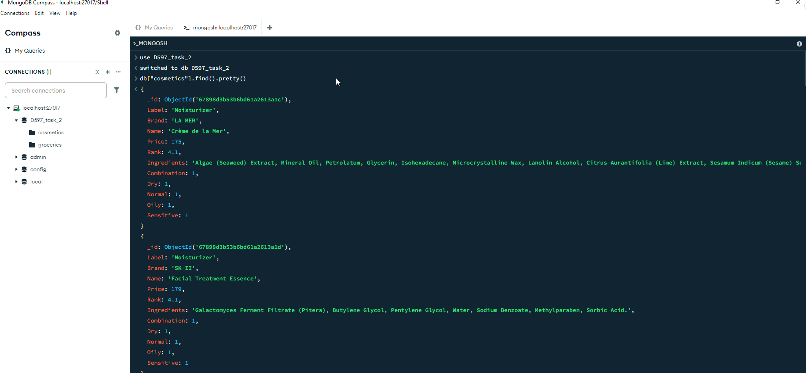



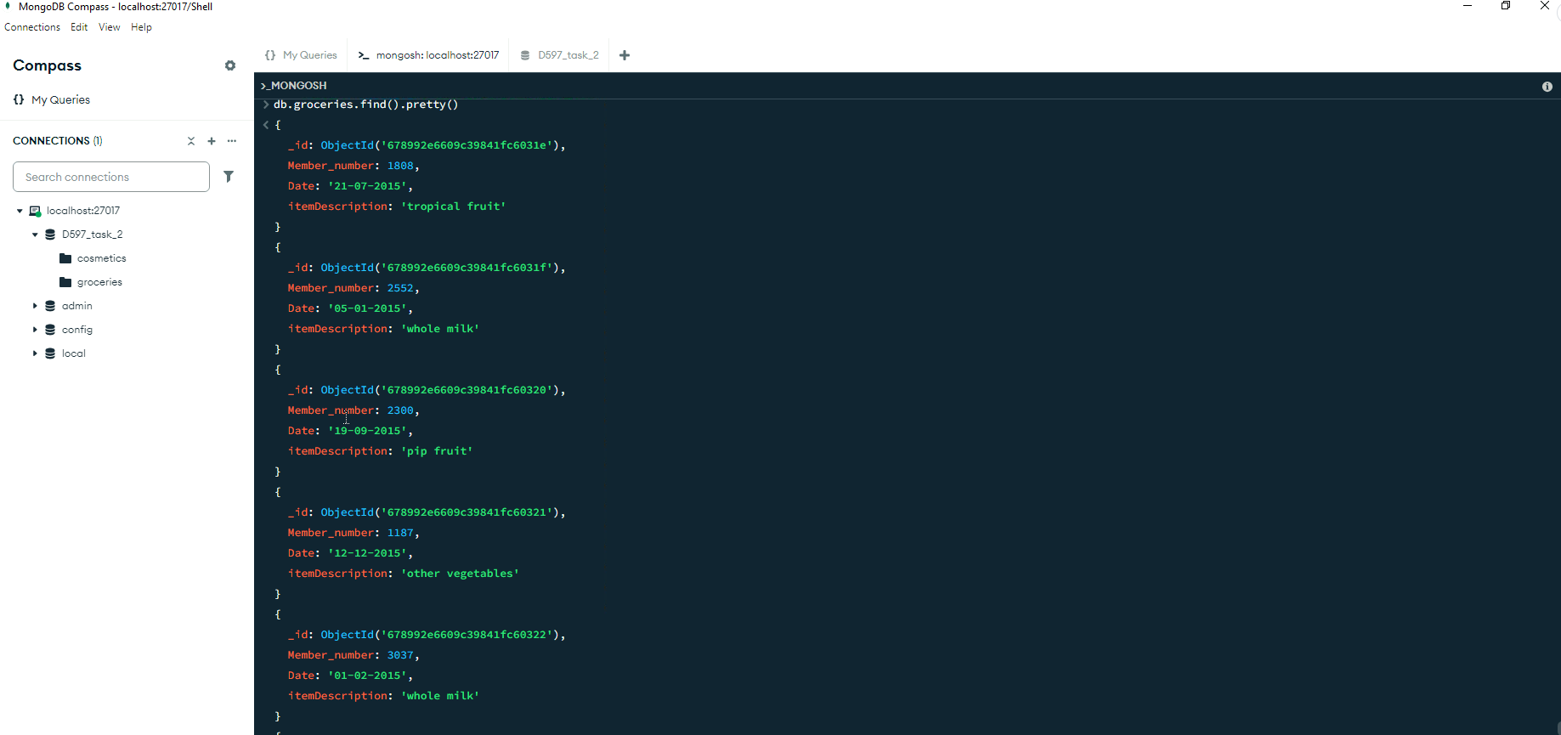

**PART D3**

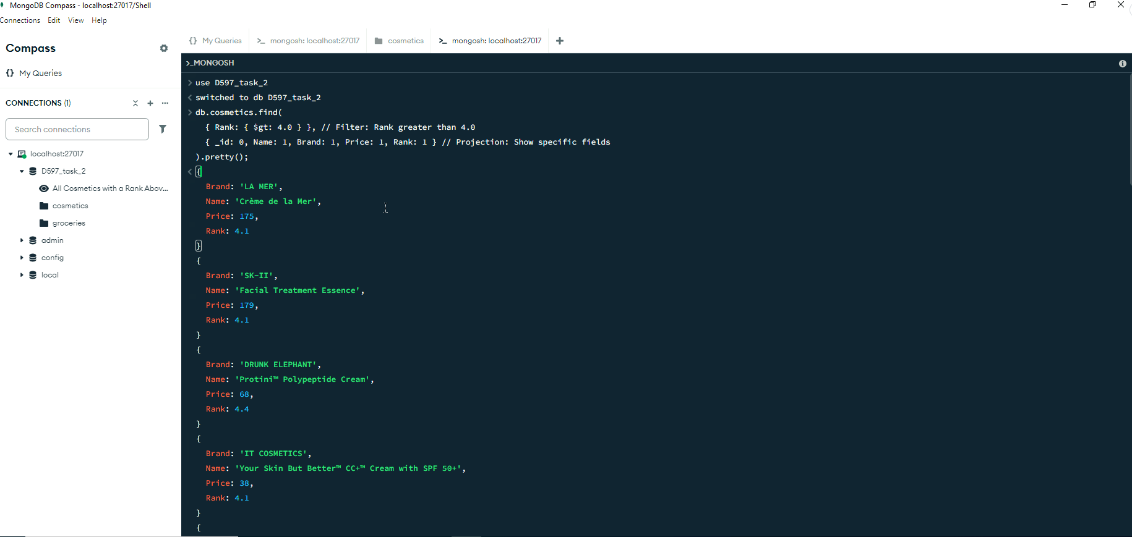

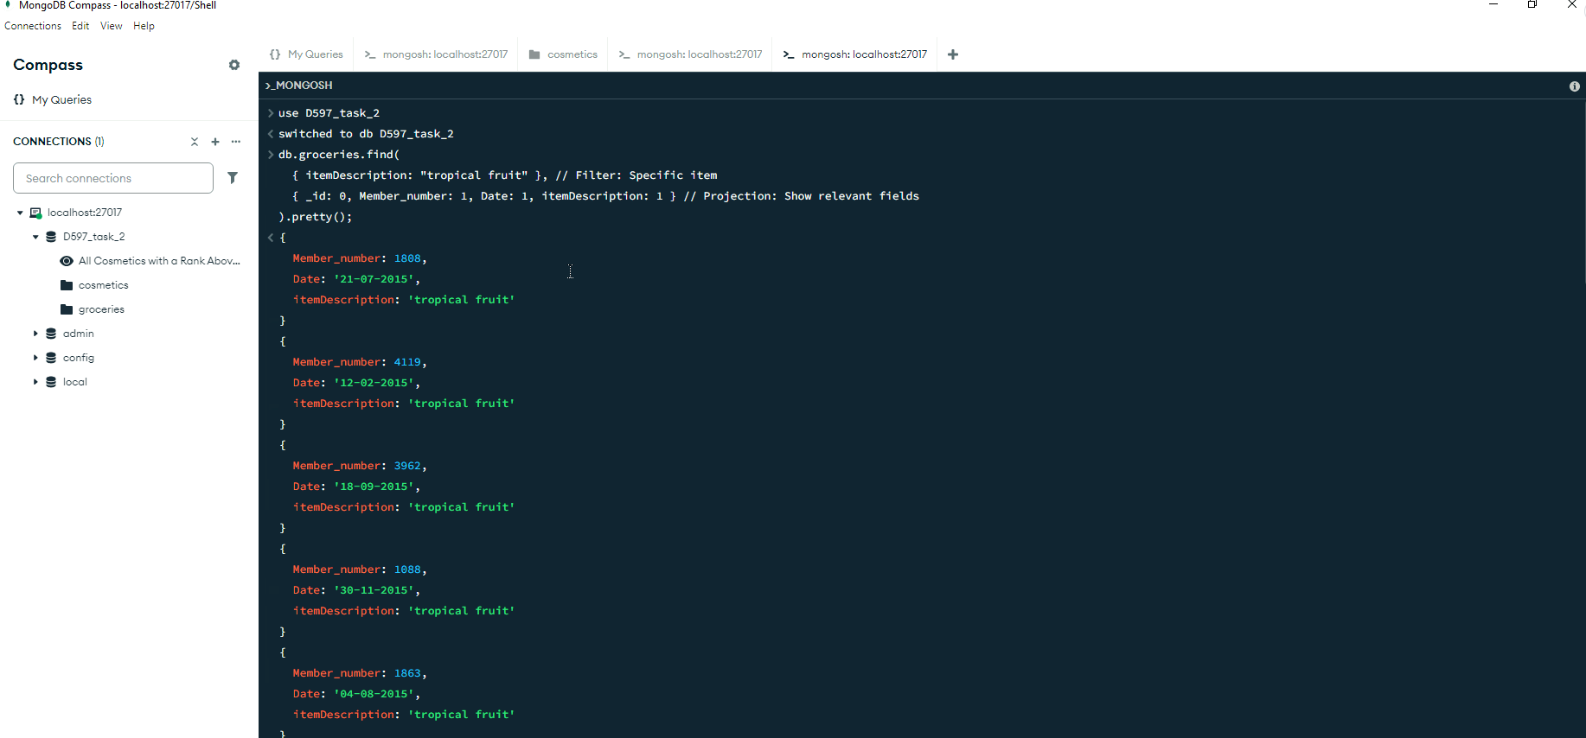



**PART D4**





